Sachin Tendulkar gifts BMW car to shuttler Saina Nehwal
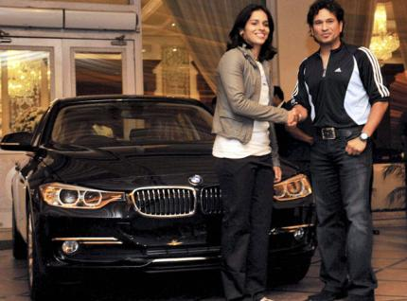
August 19, 2012, Hydrabad : Saina Nehwal on Sunday received a brand new BMW car for winning a Bronze Medal at the London Olympic - 2012 from none other than batting legend Sachin Tendulkar, who said that the world is yet to see the best of the star shuttler. "This medal means a lot for India, I am sure this medal has not come without dedication, hard work, focus and having a vision," Tendulkar said.
Responding to the accolade, Saina said she had waited for her Olympic moment since her childhood days. "I dreamt of being a Olympic champion at the age of 9...It is unbelievable to have won the medal. I am so happy. Myself winning the first medal will really change a lot of things for Badminton in India and I am sure we shall have lot more Medals in future. I hope Badminton becomes one of the most popular games, though may not be like cricket, in our Country," Saina said.

